Meandering Armadillos - Yuppy City Simulator

**All Use Case Outlines**

|  |  |  |  |
| --- | --- | --- | --- |
| **Use Case Identification and History** | | | |
| **Use Case ID:** | YCS.1 | | |
| **Use Case Name:** | Creating User Profile | **Version No:** | 1 |
| **End Objective:** | To allow a user to create a profile on Yuppie City Simulator | | |
| **Created by:** | Meandering Armadillos | **On (date):** | 1/26/19 |
| **Last Update by:** | Meandering Armadillos | **On (date):** | 1/26/19 |
| **Approved by:** |  | **On (date):** |  |
| **User/Actor:** | end user | | |
| **Business Owner**  **Name:** | N/A | **Contact Details:** | N/A |
| **Trigger:** | User | | |
| **Frequency of Use:** | Once per user | | |

|  |
| --- |
| **Preconditions** |
| 1. User does not yet have a profile. |

|  |  |  |
| --- | --- | --- |
| **Basic Flow** | | |
| **Step** | **User Actions** | **System Actions** |
| **1** | User clicks create account button | System offers inputs for username, email, and password |
| **2** | User inputs account information | System validates unique username and email.  Creates new profile in database.  System displays login page. |

|  |  |  |
| --- | --- | --- |
| **Exception Flow** | | |
| **Step** | **User Actions** | **System Actions** |
| **2** | User inputs name or email that is taken | System responds with a message that informs user to input unique name |
| **3** | User inputs incorrect name and password | System rejects name and password, and displays a message to re-enter |

|  |
| --- |
| **Post Conditions** |
| 1. A new account is established for the user and stored in database. 2. User now views login page. |

|  |
| --- |
| **Includes or Extension Points** |
| 1. Includes: Redundant Credential Validation 2. Extends: Display Credential Error |

|  |
| --- |
| **Special Requirements** |
| 1. User credentials not stored as plain-text. 2. User email MUST be unique 3. User username MUST be unique |

|  |
| --- |
| **Business Rules** |
| 1. N/A |

|  |
| --- |
| **Other Notes (Assumptions, Issues)** |
| 1. N/A |

**Use Case Diagram:**

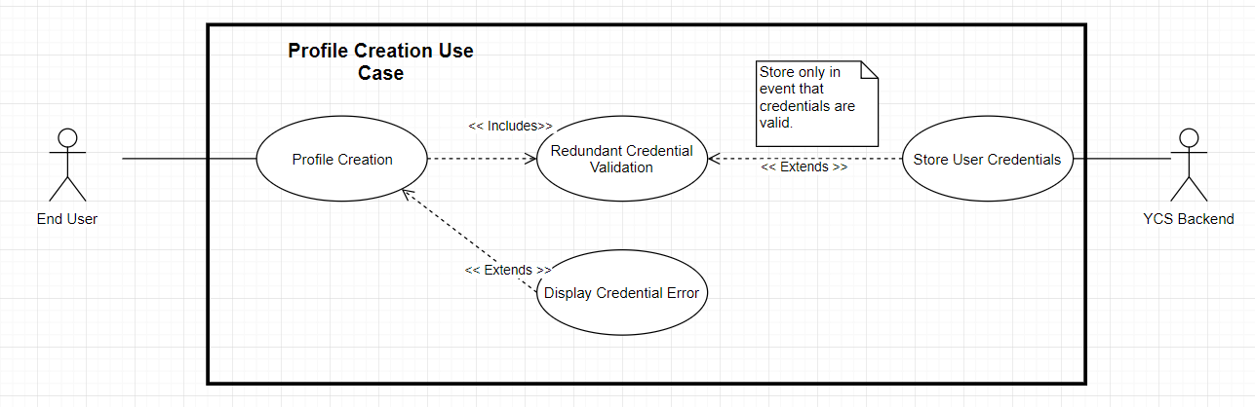

|  |  |  |  |
| --- | --- | --- | --- |
| **Use Case Identification and History** | | | |
| **Use Case ID:** | YCS.2 | | |
| **Use Case Name:** | User Login | **Version No:** | 1 |
| **End Objective:** | User is logged into their profile | | |
| **Created by:** | Nick Montaquila | **On (date):** | 1/26/19 |
| **Last Update by:** | Nick Montaquila | **On (date):** | 1/26/19 |
| **Approved by:** |  | **On (date):** |  |
| **User/Actor:** | End user | | |
| **Business Owner**  **Name:** |  | **Contact Details:** |  |
| **Trigger:** | User, system | | |
| **Frequency of Use:** | Once per use session | | |

|  |
| --- |
| **Preconditions** |
| User is not currently logged into their profile and has a profile |

|  |  |  |
| --- | --- | --- |
| **Basic Flow** | | |
| **Step** | **User Actions** | **System Actions** |
| **1** | User clicks login | System displays login page offering input for username/email and password |
| **2** | User inputs account information | System validates account info.  Logs user into their profile.  Displays home page. |

|  |  |  |
| --- | --- | --- |
| **Alternate Flow** | | |
| **Step** | **User Actions** | **System Actions** |
| **1** | User is redirected to login page from account creation | System displays login page offering input for username/email and password |
| **2** | User inputs account information | System validates account info.  Logs user into their profile.  Displays home page. |

|  |  |  |
| --- | --- | --- |
| **Exception Flow** | | |
| **2** | User inputs invalid credentials | System displays message and prompts user to re-enter credentials |

|  |
| --- |
| **Post Conditions** |
| User is logged into their account and is viewing the home page |

|  |
| --- |
| **Includes or Extension Points** |
| 1. Includes: YCS.1 (Verify Login)  2. Extends: Login Error |

|  |
| --- |
| **Special Requirements** |
| 1. Credential authentication process is secure |

|  |
| --- |
| **Business Rules** |
| N/A |

|  |
| --- |
| **Other Notes (Assumptions, Issues)** |
| N/A |

Use Case Diagram:

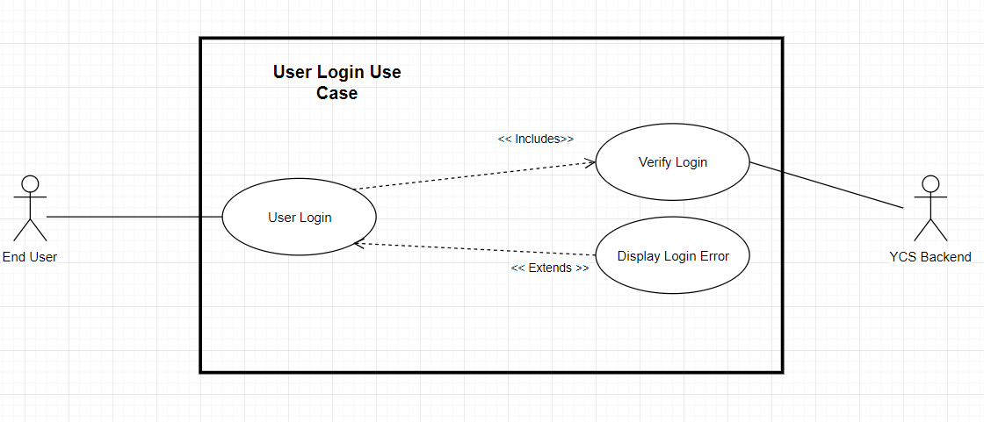

|  |  |  |  |
| --- | --- | --- | --- |
| **Use Case Identification and History** | | | |
| **Use Case ID:** | YCS.3 | | |
| **Use Case Name:** | Take Quiz | **Version No:** | 1 |
| **End Objective:** | To allow a user to complete the quiz and get a city result based on their answers | | |
| **Created by:** | Meandering Armadillos | **On (date):** | 1/27/19 |
| **Last Update by:** | Meandering Armadillos | **On (date):** | 1/27/19 |
| **Approved by:** |  | **On (date):** |  |
| **User/Actor:** | End user | | |
| **Business Owner**  **Name:** | N/A | **Contact Details:** | N/A |
| **Trigger:** | User | | |
| **Frequency of Use:** | One to many times per user | | |

|  |
| --- |
| **Preconditions** |
| 1. User has created a profile 2. User is logged in to their profile |

|  |  |  |
| --- | --- | --- |
| **Basic Flow** | | |
| **Step** | **User Actions** | **System Actions** |
| **1** | User clicks “Take Quiz” | System displays the quiz page |
| **2** | User chooses categories they wish to input information for | System compiles list of categories  Returns the categories to the user one by one |
| **3** | User chooses from 1-10 the importance of a particular category | The system saves each answer along with the category  Upon answering final question, system runs algorithm to calculate the score for each city |
| **4** | User selects “show results” | System displays a list of every city based on the score unique to the users’ inputs |
| **5** | User selects “exit” | System returns user to main |

|  |  |  |
| --- | --- | --- |
| **Alternate Flow - Branches from step 4** | | |
| **Step** | **User Actions** | **System Actions** |
| **1** | User chooses to save results of quiz | System adds quiz values to user profile |
| **2** | User adds a custom name to the quiz | System saves the quiz in a table with the custom name |

|  |  |  |
| --- | --- | --- |
| **Exception Flow** | | |
| **Step** | **User Actions** | **System Actions** |
| **2** | User inputs no categories, or invalid category | System responds with a message instructing user to check category names and re-enter |
| **3** | User inputs something other than value from 1-10 | System asks user to enter valid value |

|  |
| --- |
| **Post Conditions** |
| 1. A new quiz may be displayed and accessible from the user page, depending on if it was saved |

|  |
| --- |
| **Includes or Extension Points** |
| 1. Includes: YCS.1 (Verify Login)    1. Category Customization    2. Save Quiz with Custom Name    3. Display Initial Quiz Results |

|  |
| --- |
| **Special Requirements** |
| 1. N/A |

|  |
| --- |
| **Business Rules** |
| 1. N/A |

|  |
| --- |
| **Other Notes (Assumptions, Issues)** |
| 1. N/A |

**Use Case Diagram:**

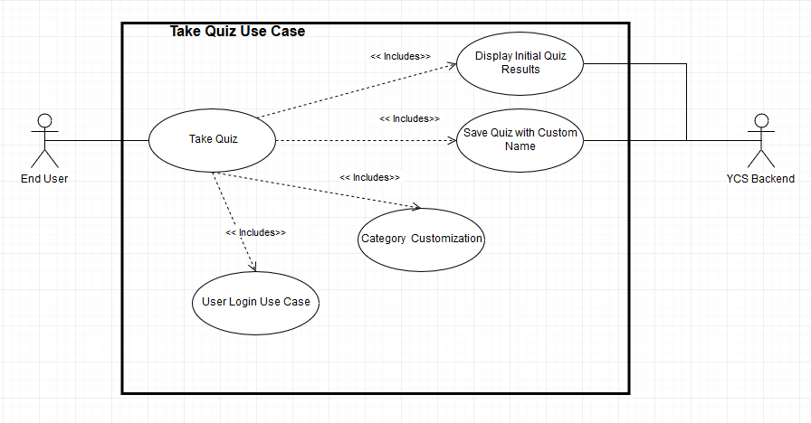

|  |  |  |  |
| --- | --- | --- | --- |
| **Use Case Identification and History** | | | |
| **Use Case ID:** | YCS.4 | | |
| **Use Case Name:** | Modify Quiz Answers | **Version No:** | 1 |
| **End Objective:** | Modified quiz answers are stored in user’s profile | | |
| **Created by:** | Nick Montaquila | **On (date):** | 1/26/19 |
| **Last Update by:** | Nick Montaquila | **On (date):** | 1/26/19 |
| **Approved by:** |  | **On (date):** |  |
| **User/Actor:** | End user | | |
| **Business Owner**  **Name:** |  | **Contact Details:** |  |
| **Trigger:** | User | | |
| **Frequency of Use:** | Unlimited | | |

|  |
| --- |
| **Preconditions** |
| User has a user profile  User is logged into their account  User has already completed the quiz |

|  |  |  |
| --- | --- | --- |
| **Basic Flow** | | |
| **Step** | **User Actions** | **System Actions** |
| **1** | User clicks modify quiz answers | System displays quiz page with user’s previous answers already filled in |
| **2** | User modifies answers and clicks save changes | System stores user’s modified answers in their profile and updates their recommendations.  System displays home page |

|  |  |  |
| --- | --- | --- |
| **Alternate Flow** | | |
| **Step** | **User Actions** | **System Actions** |
| **1** | User clicks modify quiz answers | System displays quiz page with user’s previous answers already filled in |
| **2** | User modifies answers and attempts to exit the quiz page without clicking save changes | System prompts user asking if they would like to save their changes. |
| **3** | User clicks save changes | System stores user’s modified answers and updates their recommendations.  System displays home page. |

|  |  |  |
| --- | --- | --- |
| **Alternate Flow** | | |
| **Step** | **User Actions** | **System Actions** |
| **1** | User clicks modify quiz answers | System displays quiz page with user’s previous answers already filled in |
| **2** | User modifies answers and attempts to exit the quiz page without clicking save changes | System prompts user asking if they would like to save their changes. |
| **3** | User clicks discard changes | System does not store user’s changes.  System displays home page. |

|  |  |  |
| --- | --- | --- |
| **Exception Flow** *<identify system and data error conditions that could occur for each step in the normal and alternate flow>* | | |
|  |  |  |

|  |
| --- |
| **Post Conditions** |
| User’s new quiz results are stored and their recommendations are updated |

|  |
| --- |
| **Includes or Extension Points** |
| 1. Includes: YCS.1 (Verify Login)    1. YSC.3 (Take Quiz)    2. Fetch Quiz Results    3. Verify Changes 2. Extends: Display Save Changes Prompt |

|  |
| --- |
| **Special Requirements** |
| N/A |

|  |
| --- |
| **Business Rules** |
| N/A |

|  |
| --- |
| **Other Notes (Assumptions, Issues)** |
| < Any special considerations that need to be kept in mind for this use case only; identify the type of item with a tag like   * **Assumptions:** User has already completed quiz * **Issues:** |

Use Case Diagram:

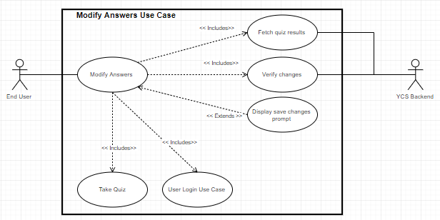

|  |  |  |  |
| --- | --- | --- | --- |
| **Use Case Identification and History** | | | |
| **Use Case ID:** | YCS.5 | | |
| **Use Case Name:** | Viewing quiz results | **Version No:** | 1 |
| **End Objective:** | Users view results of their quiz | | |
| **Created by:** | Meandering Armadillos | **On (date):** | 1/26/19 |
| **Last Update by:** | Meandering Armadillos | **On (date):** | 1/26/19 |
| **Approved by:** |  | **On (date):** |  |
| **User/Actor:** | end user, YCS backend | | |
| **Business Owner**  **Name:** |  | **Contact Details:** |  |
| **Trigger:** | User, System | | |
| **Frequency of Use:** | Once automatically after quiz. Then on determined by frequency with which user wishes to view results | | |

|  |
| --- |
| **Preconditions** |
| 1. User has user profile 2. User has results to view (has previously taken quiz) |

|  |  |  |
| --- | --- | --- |
| **Basic Flow** | | |
| **Step** | **User Actions** | **System Actions** |
| **1** | User Logs into account with credentials | System verifies login and brings user to home page |
| **2** | User selects option to view previous results | System retrieves results from user’s profile in the backend and brings user to results page |
| **3** | User views results | No action |
| **4** | User selects option to return to home page | System brings user to home page. |

|  |  |  |
| --- | --- | --- |
| **Alternate Flow: Quiz Route** | | |
| **Step** | **User Actions** | **System Actions** |
| **1** | User logs into account with credentials | System Verifies login and brings user to home page |
| **2** | Quiz Taking Use Case | System begins quiz process. Pushes user to results page automatically after finishing. |
| **3** | User views results | None |
| **4** | User selects option to return to home page | System returns user to home page |

|  |  |  |
| --- | --- | --- |
| **Exception Flow** *<identify system and data error conditions that could occur for each step in the normal and alternate flow>* | | |
| **Step** | **User Actions** | **System Actions** |
| **1 (Basic and Alt)** | User provides incorrect credentials | System rejects login attempt and prompts user to try again |
| **2 (Basic)** | User has not previously taken quiz | System will display error message. |

|  |
| --- |
| **Post Conditions** |
| User has viewed results and returned to home page |

|  |
| --- |
| **Includes or Extension Points** |
| 1. Includes: YCS.1 (User Login)    1. Fetch User Profile 2. Extends: Display No Results Error |

|  |
| --- |
| **Special Requirements** |
| 1. User should only be able to view their own results |

|  |
| --- |
| **Business Rules** |
| 1. N/A |

|  |
| --- |
| **Other Notes (Assumptions, Issues)** |
| 1. N/A |

**Use Case Diagram:**

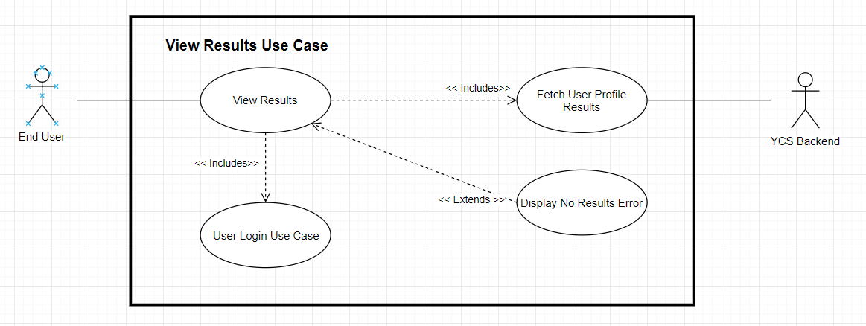

|  |  |  |  |
| --- | --- | --- | --- |
| **Use Case Identification and History** | | | |
| **Use Case ID:** | YCS.6 | | |
| **Use Case Name:** | View City Index | **Version No:** | 1 |
| **End Objective:** | User able to view all indexes of city data independent of results | | |
| **Created by:** | Meandering Armadillos | **On (date):** | 1/26/19 |
| **Last Update by:** | Meandering Armadillos | **On (date):** | 1/26/19 |
| **Approved by:** |  | **On (date):** |  |
| **User/Actor:** | end user, YCS backend | | |
| **Business Owner**  **Name:** |  | **Contact Details:** |  |
| **Trigger:** | User | | |
| **Frequency of Use:** | Unknown. Depends on how frequently user wishes to view index | | |

|  |
| --- |
| **Preconditions** |
| 1. User has user profile |

|  |  |  |
| --- | --- | --- |
| **Basic Flow** | | |
| **Step** | **User Actions** | **System Actions** |
| **1** | User Logs into account with credentials | System verifies login and brings user to home page |
| **2** | User selects option to view city index | System retrieves city index from backend and presents filtering options |
| **3** | User selects filtering option (most walkable, most green, etc.) | System filters information based on user selection and presents results. |
| **4** | User exits city index | System brings user to home page. |

|  |
| --- |
| **Post Conditions** |
| User has viewed city index with desired filter. |

|  |
| --- |
| **Includes or Extension Points** |
| 1. Includes: YSC.1 (User Login)    1. Retrieve City Information    2. Choose Filter Type |

|  |
| --- |
| **Special Requirements** |
| 1. System must bring results up in legible format 2. System must bring up results in reasonable time. |

|  |
| --- |
| **Business Rules** |
| 1. N/A |

|  |
| --- |
| **Other Notes (Assumptions, Issues)** |
| 1. N/A |

**Use Case Diagram:**

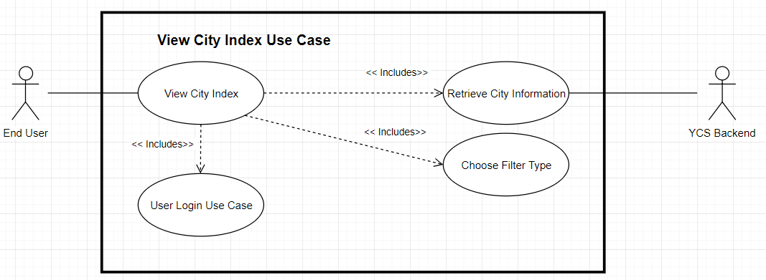

|  |  |  |  |
| --- | --- | --- | --- |
| **Use Case Identification and History** | | | |
| **Use Case ID:** | YCS.7 | | |
| **Use Case Name:** | Modifying User Profile | **Version No:** | 1 |
| **End Objective:** | User modifies aspects of their profile | | |
| **Created by:** | Meandering Armadillos | **On (date):** | 1/26/19 |
| **Last Update by:** | Meandering Armadillos | **On (date):** | 1/26/19 |
| **Approved by:** |  | **On (date):** |  |
| **User/Actor:** | end user, YCS backend | | |
| **Business Owner**  **Name:** |  | **Contact Details:** |  |
| **Trigger:** | User | | |
| **Frequency of Use:** | Infrequent. Based on when user needs to modify profile information. | | |

|  |
| --- |
| **Preconditions** |
| 1. User has user profile |

|  |  |  |
| --- | --- | --- |
| **Basic Flow** | | |
| **Step** | **User Actions** | **System Actions** |
| **1** | User Logs into account with credentials | System verifies login and brings user to home page |
| **2** | User selects option to modify profile | System retrieves user profile information from backend and brings user to profile modification page |
| **3** | User changes username, password, or email and submits to server | System verifies validity of new credentials and stores them in the backend. |
| **4** | User exits account modification page. | System brings user to home page. |

|  |  |  |
| --- | --- | --- |
| **Exception Flow** *<identify system and data error conditions that could occur for each step in the normal and alternate flow>* | | |
| **Step** | **User Actions** | **System Actions** |
| **1** | User provides incorrect credentials | System rejects login attempt and prompts user to try again |
| **3** | User does not enter valid new credentials | System will display error message and reject credential update |

|  |
| --- |
| **Post Conditions** |
| User has updated account information |

|  |
| --- |
| **Includes or Extension Points** |
| 1. Includes: YSC.1 (User Login)    1. Redundant Credential Validation 2. Extends: Display Credential Error |

|  |
| --- |
| **Special Requirements** |
| 1. User data must NOT be stored or transferred in plain text 2. User must maintain log-in for current session after changes are made. |

|  |
| --- |
| **Business Rules** |
| 1. N/A |

|  |
| --- |
| **Other Notes (Assumptions, Issues)** |
| 1. N/A |

**Use Case Diagram:**

